ANNEXURE-1

The Head of Department (HoD), Department of Computer Science Arya College of Engineering & I.T., Jaipur Rajasthan.

Sub: Undertaking and Declaration in regard to Invention made by the undersigned

In regards to the invention made by us, we have requested our HoD to forward the proposal for filing application for patent. In this connection we reiterate the following facts.

1. Lora Technology enable secure and efficient smart parking system

The invention made by us is completely new and is on account of inventive steps taken by us, it has not been published.

i. There is no lawful ground of objection to the grant of patent in respect of our invention.

ii. We have perused the available literature on the subject and we confirm that no invention has been made by any person of the type mentioned as item no. (i) Above.

iii. We undertake to keep you poste of developments in regard to correspondence/ business discussion if any, pertaining to the above mentioned invention, in future.

iv. We give below the declaration for assignment of rights to Department of Computer Science Arya College of Engineering & I.T., Jaipur Rajasthan.

In view of the above facts, we request you to kindly expedite the filing of the application. Yours faithfully

Name(s) of the Inventor(s)

(Signature)

1. Dr. Ashok Kumar Kajla
2. Anshika Gupta

2. Sumant Kumar

3. Shivani Yadav

4. Aditya Shukla

5. Vishal Sharma

ANNEXURE-2

DECLARATION BY INVENTOR(S)

We declare that the authorized official of Department of Computer Science, Arya College of Engineering & I.T., Jaipur Rajasthan, who has signed the application for the invention under reference as applicant is our assignee.

Date:

INVENTOR(S) NAME (in full with expanded initials)

SIGNATURE

1. Dr. Ashok Kumar Kajla
2. Anshika Gupta

2. Sumant Kumar

3. Shivani Yadav

4. Aditya Shukla

5. Vishal Sharma

Signature of two witnesses along with their names and addresses.

|  |  |  |  |
| --- | --- | --- | --- |
| **S.No.** | **NAME** | **DESIGNATION** | **SIGNATURE** |
| **1.** | **Aditya Shukla** | **Andriod Application Developer** | **aditya** |
| **2.** | **Sumant Kumar** | **Hardware R&D** | **sumant** |

**FORM 1**

**THE PATENTS ACT, 1970 (39 of 1970) & The Patents Rules, 2003**

**APPLICATION FOR GRANT OF PATENT (See sections 7, 54 & 135 and rule 20(1))**

**(FOR OFFICE USE ONLY)**

|  |  |  |  |  |
| --- | --- | --- | --- | --- |
| Application No: | Filing Date | : Amount of Fee Paid: | CBR No: | Signature: |

**1. APPLICANT(S)**

Name

Nationality

Address

Department of Computer Science, Arya College of Engineering & IT, Jaipur

An Indian Educational Institute

Arya College of Engineering and Information Technology, SP-42, Delhi Road, Near Hotel Le- Meridian, RIICO Industrial Area, Kukas, Rajasthan 302028

**2. INVENTOR(S)**

Name: Dr. Ashok Kumar Kajla,Anshika Gupta,Sumant Kumar,Aditya Shukla,Shivani Yadav,Vishal Sharma

Nationality: Indian

Address: Arya College of Engineering and Information Technology, SP-42, Delhi Road, Near Hotel Le- Meridian, RIICO Industrial Area, Kukas, Rajasthan 302028

**3. TITLE OF THE INVENTION : Lora Technology Enable Secure and Energy Efficient Smart Parking System**

**4. ADDRESS FOR CORRESPONDENCE OF APPLICANT/ AUTHORISED PATENT AGENT IN INDIA**

Head,

Department of Computer Science Department Arya College of Engineering & IT, Jaipur

Telephone No. 0141 660 4555 Fax No. -- E-mail:

**5. ~~PRIORITY PARTICULARS OF THE APPLICATION (S) FILED IN CONVENTIONCOUNTRY -~~Not applicable**

~~Country~~

~~Application number~~

~~Filing date~~

~~Name of the Applicant~~

~~Title of the invention~~

**6~~. PARTICULARS FOR FILING PATENT COOPERATION TREATY (PCT) NATIONAL PHASE APPLICATION~~ -Not applicable**

~~International Application Number~~

~~International filing date as allotted by the receiving office~~

**7. ~~PARTICULARS FOR FILING DIVISIONAL APPLICATION~~-Not applicable**

**8. ~~PATICULARS FOR FILING PATENT OF ADDITION~~ Not applicable**

~~Main application / Patent Number~~

~~Date of filing of main application~~

**9. DECLARATIONS:**

(i) **Declaration by the inventor(s)** I/We, the above named inventor(s) is/ are the true & first inventor(s) for this invention and declare that the applicant(s) herein is /are my/our assignee or legal representative.

(a)Date: 03 / 05/ 2023

(b)Signature(s)

(Dr. Ashok Kumar Kajla)(ANSHIKA GUPTA) (SUMANT KUMAR) (SHIVANI YADAV) (ADITYA SHUKLA) (VISHAL SHARMA)

**(ii) Declaration by the applicant(s) in the convention country Not applicable**

I/We, the applicant(s) in the convention country declare that the applicant(s) herein is/are my/our assignee or legal representative.

(a) Date: 03/05/2023

(b) Signature(s) ( )

c) Name(s) of the signatory

**iii) Declaration by the applicant(s):**

I/We, the applicant(s) hereby declare(s) that:- I am / We are in possession of the above-mentioned invention.

The provisional/complete specification relating to the invention is filed with this application.

The invention as disclosed in the specification uses the biological material from India and the necessary permission from competent authority shall be submitted by me/us before the grant of patent to me/ us.

There is no lawful ground of objection to the grant of patent to me/ us.

I am/We are the assignee or legal representative of true and first inventors.

The application or each of the applications, particulars of which are given in para 5 was the first application in convention country/ countries in respect of my/ our invention

I/We claim the priority from the above-mentioned application(s) filed in convention country/countries and state that no application for protection in respect of the invention had been made in a convention country before that date by me/us or by any person from which I/We derive the title.

My/Our application in India is based on international application under Patent Cooperation Treaty (PCT) as mentioned in Para 6.

The application is divided out of my/ our application particulars of which are given in para 7 and pray this application may be treated as deemed to have been filed on _________ under section 16 of the Act.

The said invention is an improvement or modification of the invention particulars of which are given in Para 8.

**10. FOLLOWING ARE THE ATTACHMENTS WITH THE APPLICATION**

**Provisional Specification**/ complete specification Complete specification (in conformation with the international application)/ as amended before the International Preliminary Examination Authority (IPEA), as applicable (2 copies), No. of pages No. of claim Drawings (in conformation with the international application)/ as amended before the International Preliminary Examination Authority (IPEA), as applicable (2 copies), No. of sheets Priority documents Translation of priority document/Specification/International Search Report Statement and undertaking on Form 3 Power of authority Declaration of inventor ship on Form5 Sequence listing in electronic form

Fee Rs**.** in Cash/ Cheque/ Bank Draft bearing no Date...............on.................Bank. I/We hereby declare that to the best of my/our knowledge, information and belief the fact and matters stated herein are correct and I/We request that a patent may be granted to me/ us for the said invention.

Dated this Wednesday day of 03/05/2023

(The Head Department of Computer Science Department, Arya College of Engg. & I.T., Jaipur, Rajasthan.) The patent office, at **New Delhi**

**FORM 2**

**THE PATENT ACT 1970 (39 OF 1970) & The Patents Rules, 2003 PROVISIONAL/COMPLETE SPECIFICATION**

1. **TITLE OF THE INVENTIONS**

**2. APPLICANT(S)**

(a) NAME: Department of Computer Science, Arya College of Engg. &I.T , Jaipur

(b) NATIONALITY: An Indian Educational Institute

(c) ADDRESS: Arya College of Engg. & I.T.,, SP-42, RIICO Industrial Area, Kukas, Rajasthan 302028

1. **PREAMBLE TO THE DESCRIPTION**

**PROVISIONAL(should contain)**

The following specification describes the invention.

**COMPLETE (should contain)**

The following specification particularly describes the invention and the manner in

which is to be performed.

1. **DESCRIPTION**

**Field of the invention**: The main important benefit of a smart parking system is its advanced technology. It follows the latest technologies and concepts to assure profitable outcomes. The design and implementation of smart parking is very easy to supervise and manage. This system can be easily handled by the staff members because of its well-organized structure.

Objective

•Develop a LoRa-based sensor network to detect parking spot availability

• Implement a cloud-based platform to store and process data from the sensor network

•Develop a mobile application for drivers to view parking spot availability in real-time

•Create a web-based dashboard for parking lot operators to monitor and manage their lots.Problem Statement

In recent research in metropolitan cities the parking management problem can be viewed from various angles such as high vehicle density on roads. This results in annoying issues for the drivers to park their vehicles as it is very difficult to find a parking slot.

The drivers usually waste time and effort in finding parking space and end up parking their vehicles finding a space on the street which further leads to space congestion. In worst case, people fail to find any parking space especially during peak hours and festive season.

**Background of the invention:** The smart parking system using LoRa technology has emerged as an innovative solution to address the increasing problem of parking in urban areas. The background of this invention can be traced to the challenges faced by drivers in finding available parking spots in busy cities, resulting in traffic congestion and wasted time and energy.

The smart parking system using LoRa technology aims to provide drivers with real-time information on parking availability, enabling them to locate and reserve parking spots conveniently using a mobile application. The system comprises of sensors installed in parking spaces that use LoRa technology to communicate occupancy data to a central gateway. The gateway then transmits this data to a cloud server, where it can be accessed by drivers via a mobile application.

The use of LoRa technology in the smart parking system enables long-range communication between the sensors and the gateway, ensuring reliable and low-power data transmission. This technology also allows for easy installation and scalability, making it suitable for implementation in various environments, including city streets, shopping malls, and office buildings.

The smart parking system using LoRa technology has the potential to reduce traffic congestion, improve the parking experience for drivers, and promote sustainability by minimizing the time and energy spent searching for parking. Moreover, the system can generate valuable data insights that can be used to optimize parking management and inform city planning decisions.

Overall, the smart parking system using LoRa technology is an example of how innovative solutions can be developed to address complex urban problems and improve the quality of life in cities.

**Objective of invention:** The objective of implementing a smart parking system using LoRa technology is to efficiently manage and monitor parking spaces in a city or a building complex. The system would allow drivers to easily locate available parking spaces, reserve them in advance, and pay for the parking spot using a mobile application.

The LoRa technology enables long-range communication between the sensors and the gateway, allowing real-time monitoring of parking spaces' occupancy and availability. This data can be used to generate insights and optimize parking management, reducing traffic congestion and minimizing the time and energy spent searching for parking.

Overall, the objective of a smart parking system using LoRa technology is to improve the parking experience for drivers while promoting sustainability and reducing the environmental impact of parking.

**Description of Method:**

Identify the parking areas: The first step is to identify the parking areas where the smart parking system will be deployed. This could include city streets, shopping malls, or office buildings.

Install the sensors: Once the parking areas have been identified, the next step is to install the LoRa sensors in each parking space. These sensors will detect the presence or absence of a vehicle and transmit occupancy data to the gateway.

Install the gateway: The gateway serves as the central hub for the smart parking system, receiving occupancy data from the sensors and transmitting it to the cloud server. The gateway should be installed in a location that provides optimal coverage and connectivity to the sensors.

Connect to the cloud server: The gateway should be connected to the cloud server, where occupancy data can be stored and accessed by the mobile application.

Develop the mobile application: The mobile application is a key component of the smart parking system, providing drivers with real-time information on parking availability, allowing them to reserve parking spots, and enabling them to pay for parking. The mobile application should be designed to be user-friendly and compatible with a wide range of devices.

Test and optimize the system: Once the system is deployed, it should be tested to ensure that it is working as intended. Any issues should be identified and addressed promptly, and the system should be optimized to improve its performance and reliability.

Maintain and update the system: The smart parking system using LoRa technology requires ongoing maintenance and updates to ensure that it continues to function optimally. This could include regular sensor calibration, software updates, and hardware upgrades.

**Drawings, Figures:**

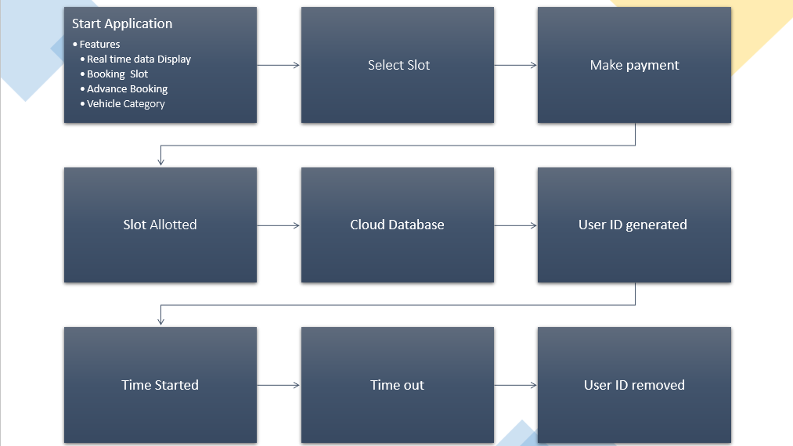

Flow Chart of the System

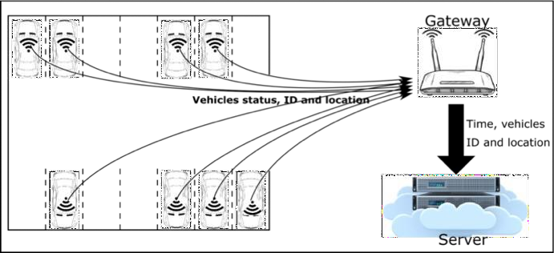

Summary of the Approaches

**Some Checks:**

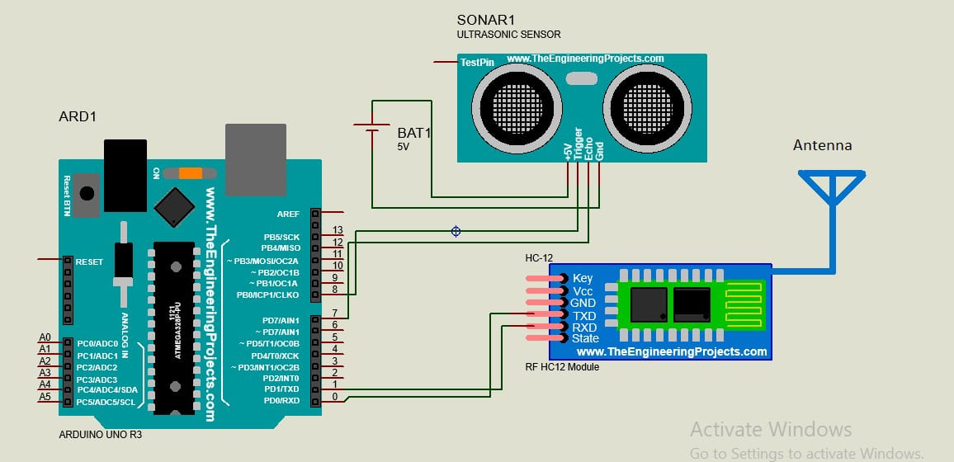

**Circuit Diagram**

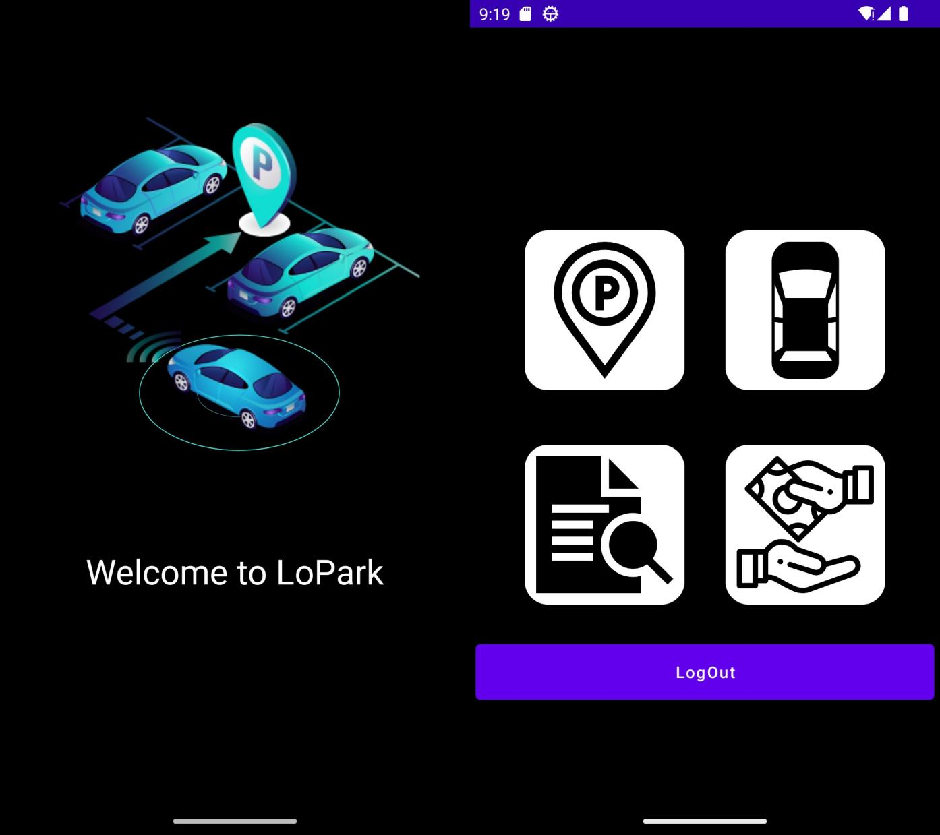

**Andriod Application**

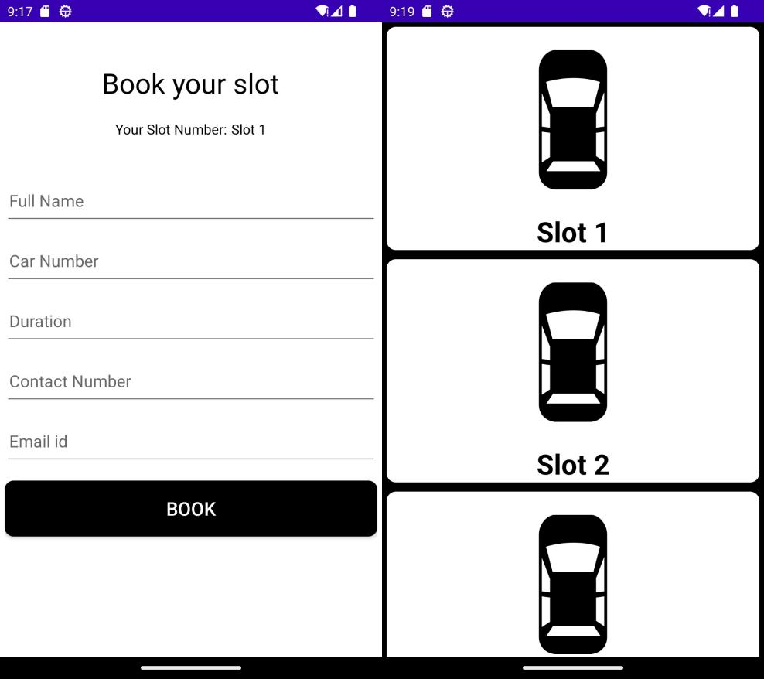

**Andriod Application**

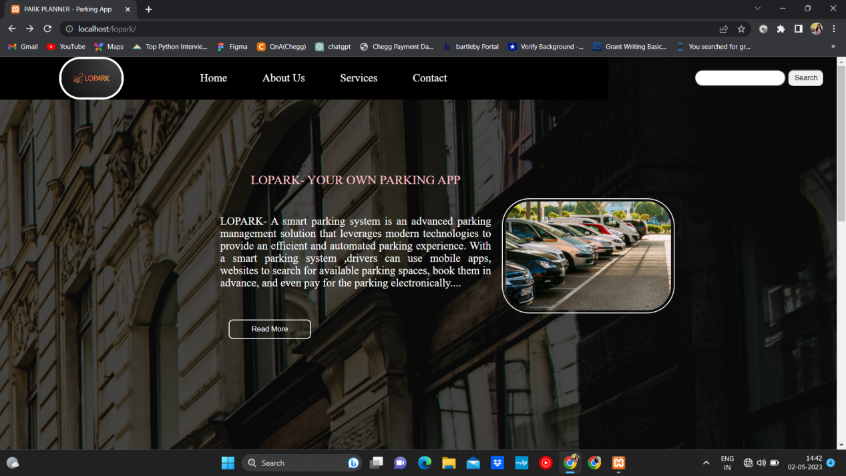

**Website**

**Signatures NAME (in full with expanded initials)**

**SIGNATURE**

**Fig. <no.>**

(The Head, Department of Computer Science, Arya College of Engg. & I. T., Jaipur, Rajasthan.)

**Description of the drawing:**

The Fig. <no.> shows the description of the whole process involved in the proposed irrigation system. The process completed in following steps:

**2. CLAIMS** (not applicable for provisional specification. Claims should start with the preamble – **“I/We claim”** on separate page)

**We claimed the following claims:**

**3. DATE AND SIGNATURE** (To be given at the end of last page of specification)

Dated this ...... day of ........20.....

_________________(Head , Computer Science , Arya College of Engg. & I.T., Jaipur)

1. **ABSTRACT**

The LoRa technology Enable Secure and Energy Efficient Smart Parking System has emerged as a potential solution. This innovative approach aims to provide drivers with real-time information on parking availability, enabling them to locate and reserve parking spots using a mobile application. The system uses LoRa sensors installed in each parking space to communicate occupancy data to a central gateway, which transmits the data to a cloud server accessible by the mobile application.

The smart parking system using LoRa technology has the potential to reduce traffic congestion, improve the parking experience for drivers, and promote sustainability by minimizing the time and energy spent searching for parking. Moreover, the system can generate valuable data insights that can be used to optimize parking management and inform city planning decisions.

Overall, the smart parking system using LoRa technology represents an innovative solution to address the complex problem of parking in urban areas. It has the potential to enhance the quality of life in cities, promote sustainable transportation, and improve the overall efficiency of parking management.

Head computer science department ,Arya College of Engg. & I.T., SP-42, Delhi Road, , RIICO Industrial Area, Kukas, Rajasthan 302028, India

**FORM 3**

THE PATENTS ACT, 1970 (39 of 1970) & THE PATENT RULES, 2003 **STATEMENT AND UNDERTAKING UNDER SECTION 8** (See section 8, rule 12)

1. Name of applicant(s) 2. Name, address and nationality of the joint applicant

I/We Head , Department of computer science department, Arya college of engg. & I.T., Jaipur hereby declare **:-**

3. Name and address of the assignee

Dated this Wednesday day of 03/05/2023

4. To be signed by the applicant or his authorized patent agent

(iii) that the rights in the application(s) has/have been assigned to Head, Department of computer science , Arya College of Engg. & I. T. that I/we undertake that upto the date of grant of the patent by the controller, I/We would keep the him informed in writing the details regarding corresponding applications for patents filed outside India within three months from the date of filing of such application.

i. that I/we have not made any application for the same/substantially the same invention outside India.

OR ii. that I/we who have made this application

No...........dated..........alone/jointly with..............made for the same/substantially same invention, application(s) for patent in the other countries, the particulars of which are given below:

application publication grant

5. Name of the natural person who has signed

Signature (.....................................)

(Head Department of Computer Science), Arya College of Engg. &I.T., SP-42, Delhi Road, RIICO Industrial Area, Kukas, Rajasthan 302028, India)

To ,

The Controller of Patents,

The Patent Office,

New Delhi